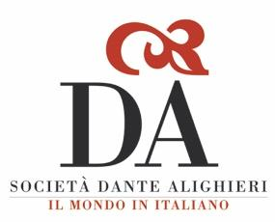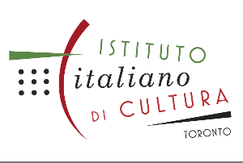
Join the Italian Book Club of Vancouver, BC
Sponsored by Dante Alighieri Society of BC and Italian Institute of Culture Toronto.
Meet other bibliophiles, share ideas and deepen your understanding of Italian literature, history and culture.
The Italian Book Club is FREE and open to all those in Canada interested in friendly and thought-provoking discussions on Italian books: fiction, non-fiction, classics, prize-winners, etc.
Discussions are in Italian. Intermediate to advanced level of Italian is recommended.
The Italian Book Club meets ONLINE on ZOOM once a month.

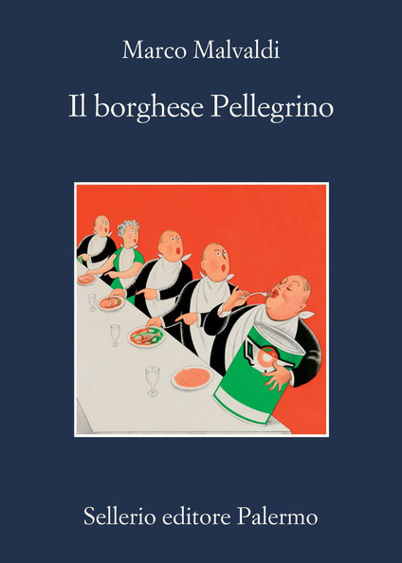

TUESDAY FEBRUARY 15th, 2022 at 5:30 PM
(8:30 PM Toronto / Montreal Time)
Discussion on the book
Il borghese pellegrino, by Marco Malvaldi
Coordinator: Benedetta Diamanti

If you are new to the Italian Book Club and wish to join the meetings, please
e-mail info@dantesocietybc.ca
and receive the ZOOM link.
Schedule and more info: www.dantesocietybc.ca/bookclub

